Binary Puzzle #1

What is your age in binary?

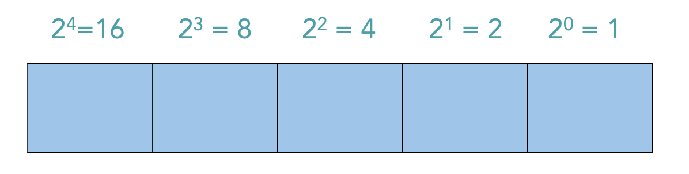

Binary Puzzle #2

What is your name in binary?







Example Circuit #1

What are the states of the bits at the output?

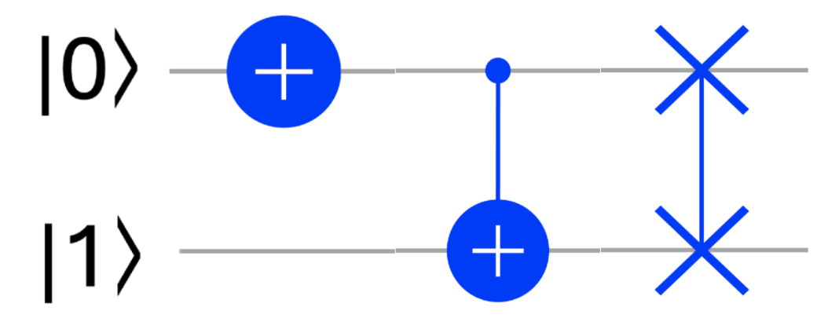

Example Circuit #2

What are the states of the bits at the output?

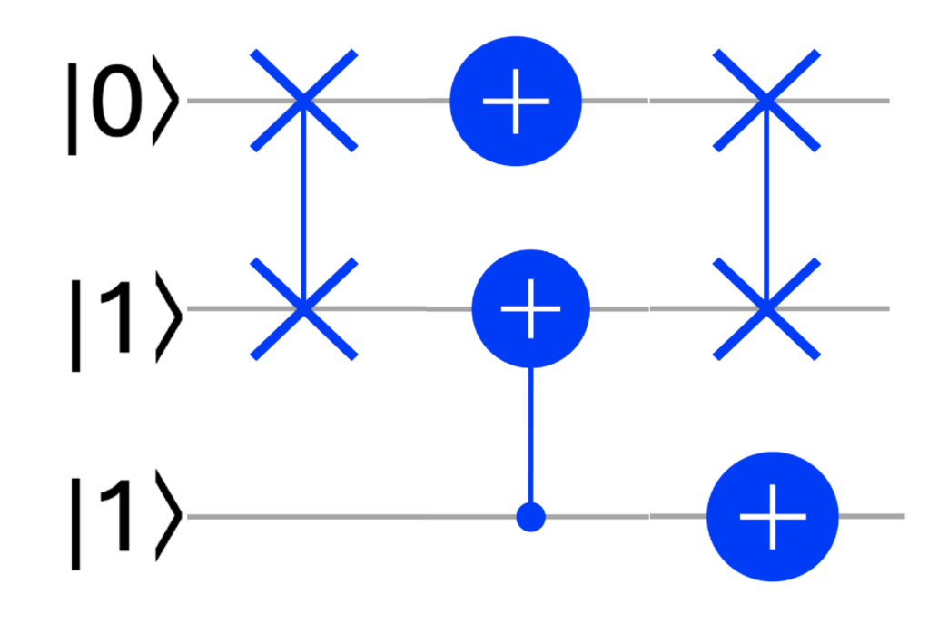

Example Circuit #3

What are the states of the bits at the output?

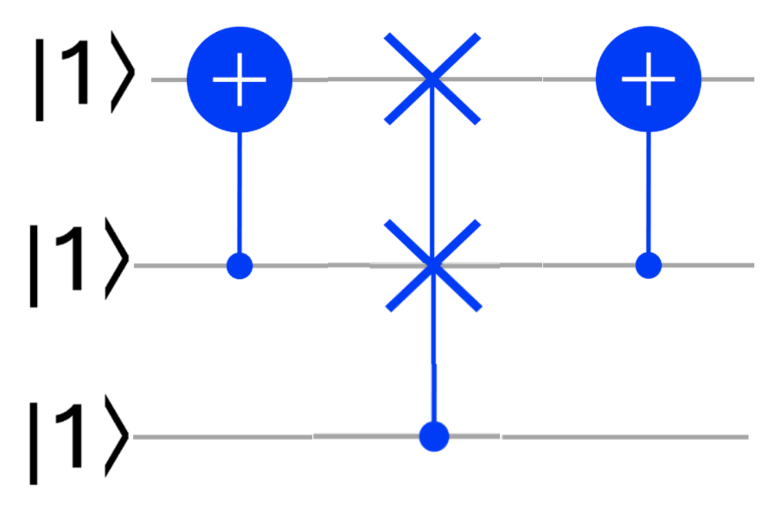

Example Circuit #4

What are the states of the bits at the output?

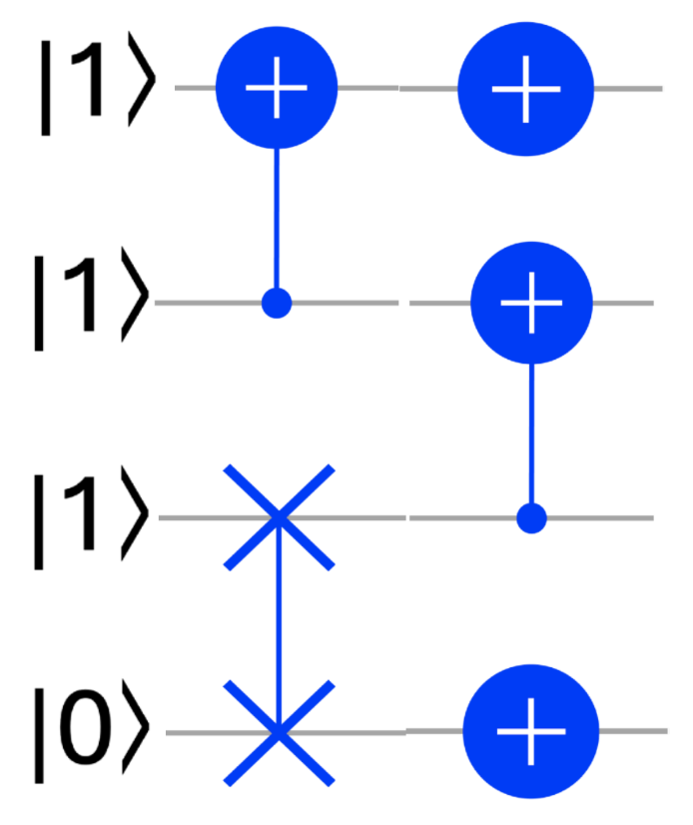

**Create Two Circuits to try to Stump Your Peers**